

**Practice Lab Assignments – Object Oriented Programming 1**

**Note: 1. Submission only via E-CLASS is acceptable (If you have any issue with E-CLASS, Please consult IT Dept. )**

**2. Do not plagiarize on doing your work, if we catch student doing so, he/she will get ZERO for the Assignment.**

Lab Assignment -5

(Week #6: Control Structure (3) –for/do-while/ Nested loop)

1. Write a Program to print stars Sequence1.

A

BB

CCC

DDDD

EEEEE

2. Write a Program to print stars Sequence2.

       1

       1 2   
    1 2 3  
 1 2 3 4

1 2 3 4 5

3. Program to print star Sequences3.

      *  
   ***  
 *****

4. Program to print Sequence4

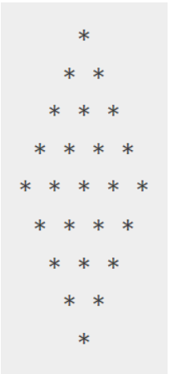

5. Write a program to add first seven terms of the following series using for loop:

1/!1+ 2/!2 + 3/!3 + ………………….